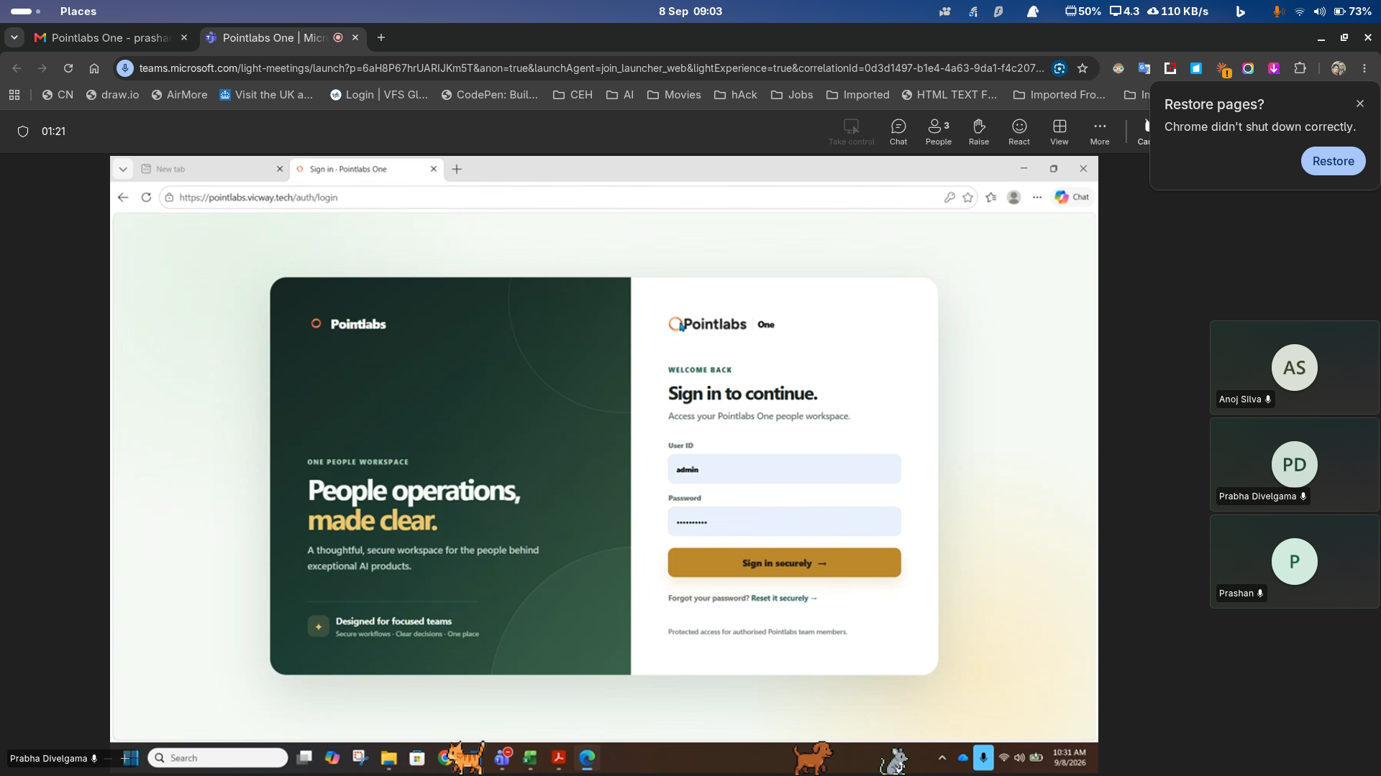
Pointlabs – Left eka poddk loku karanna, dakunu petta logo eka epa, pointslabsone nama witarai oni, “O” eka orange karala – Branding colors oni.

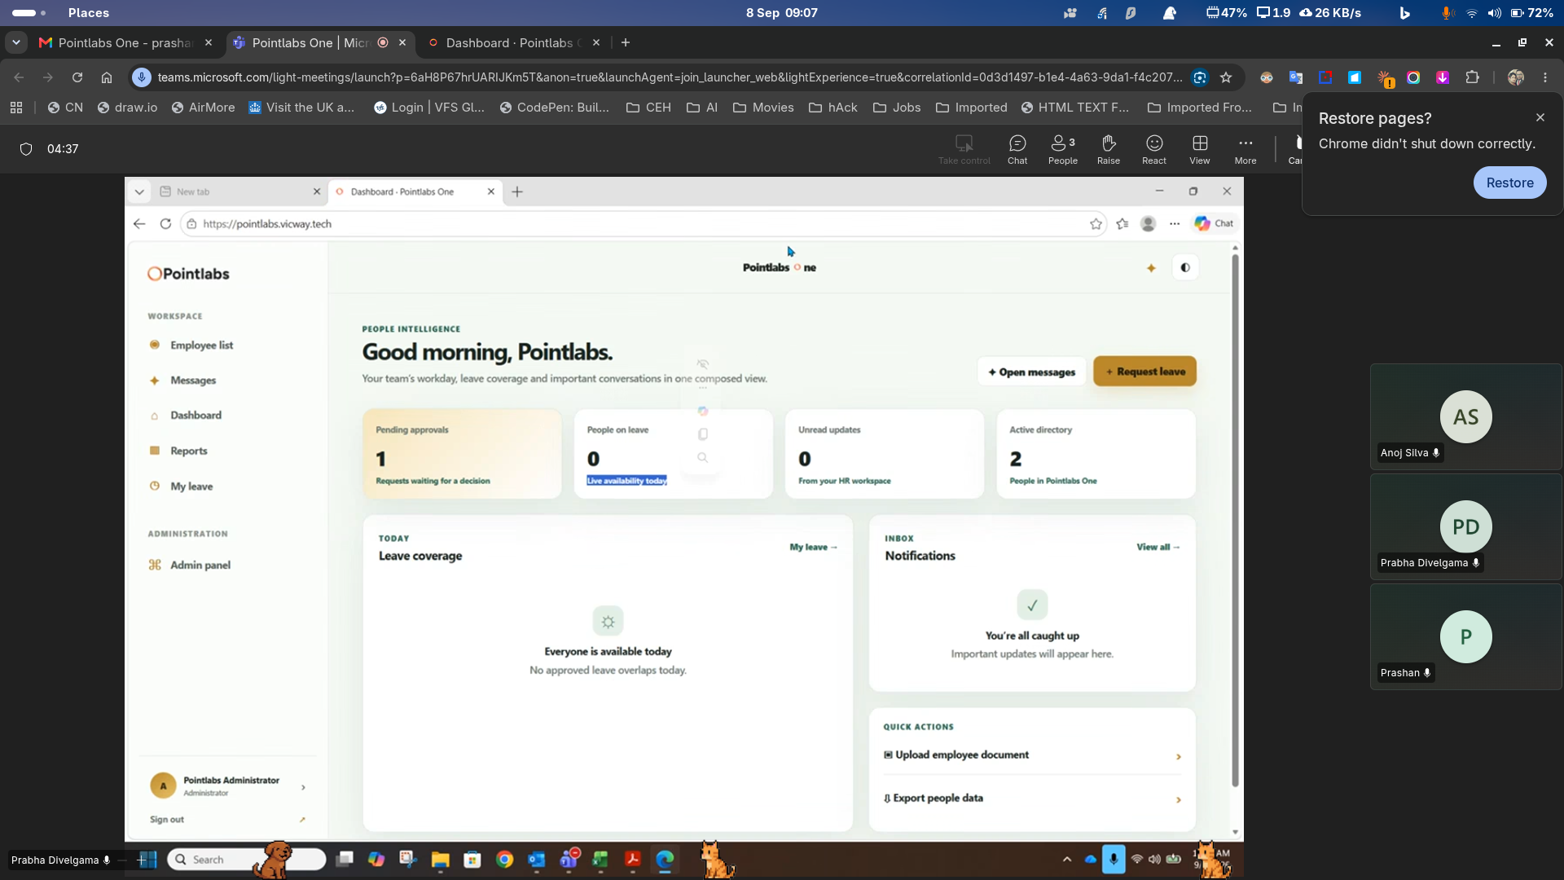
Live available – remove

Unread approve – need to replace,
Active directory – Total Active Employee

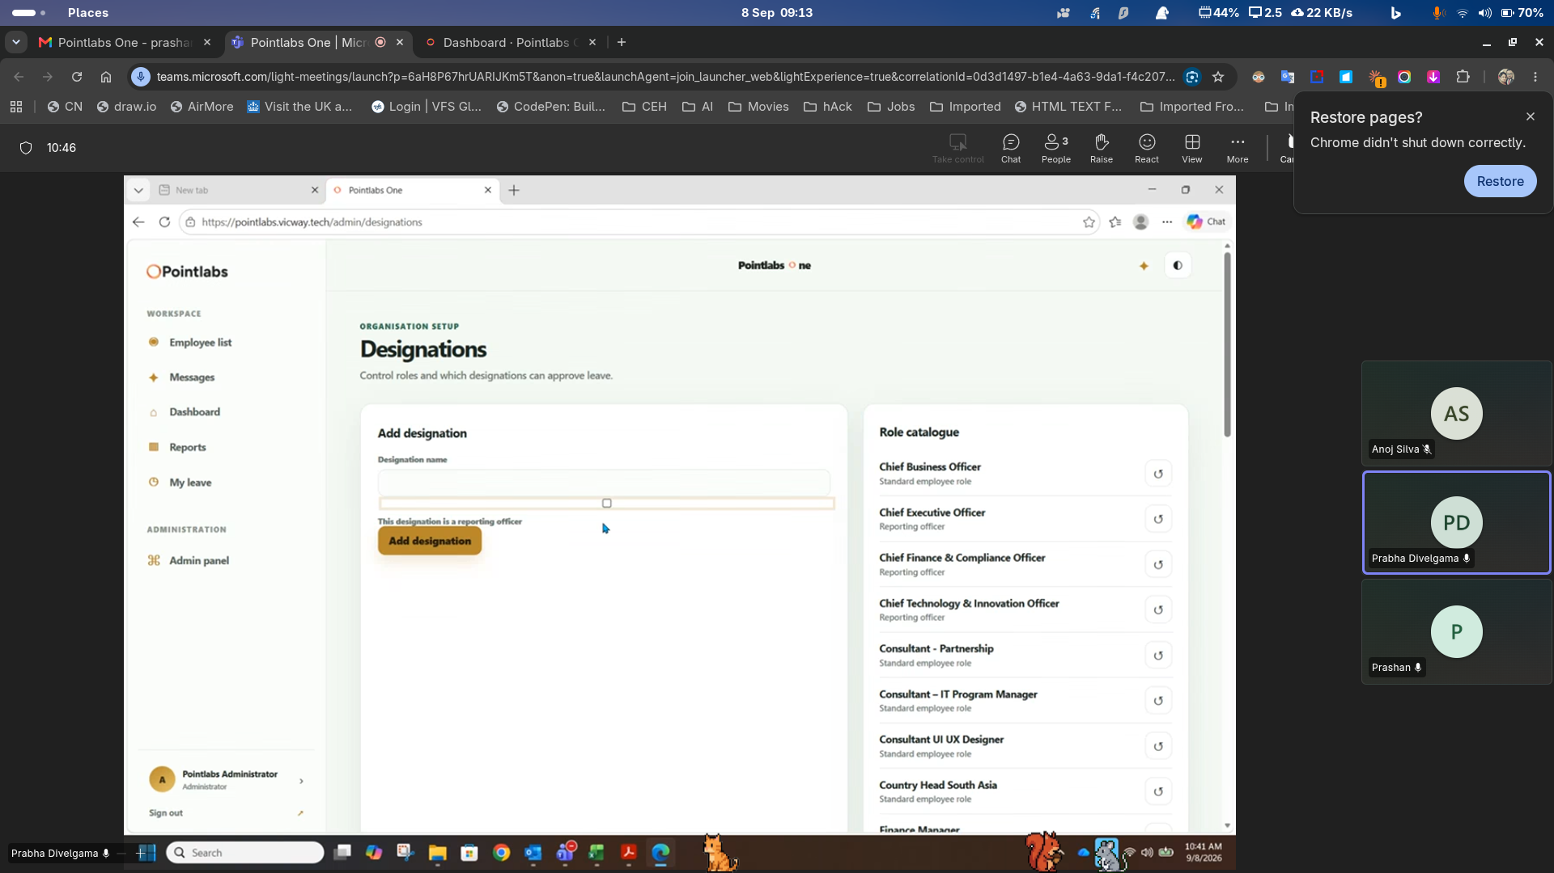
Reporting officer – needs to be select by the admin, not hard coded

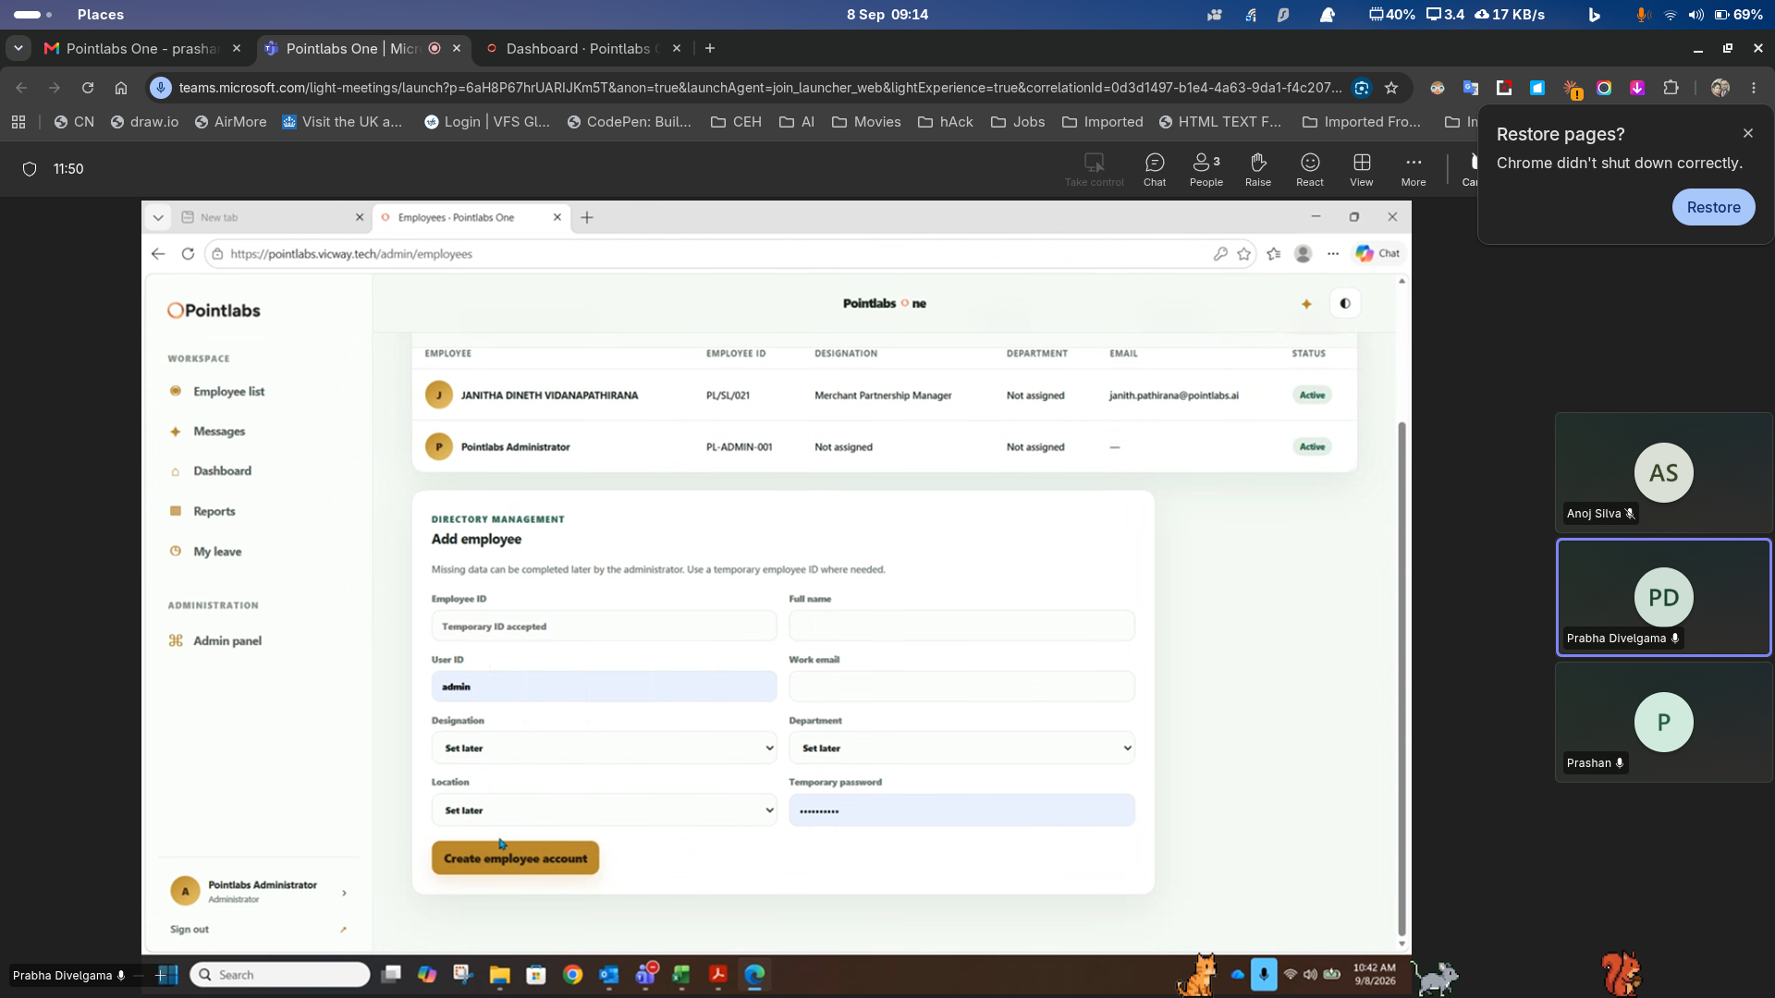
Employee – Edit / delete needs to add.
Resign, Date of Join, Birthday, and adding leave balances, public holiday apply wenna oni.

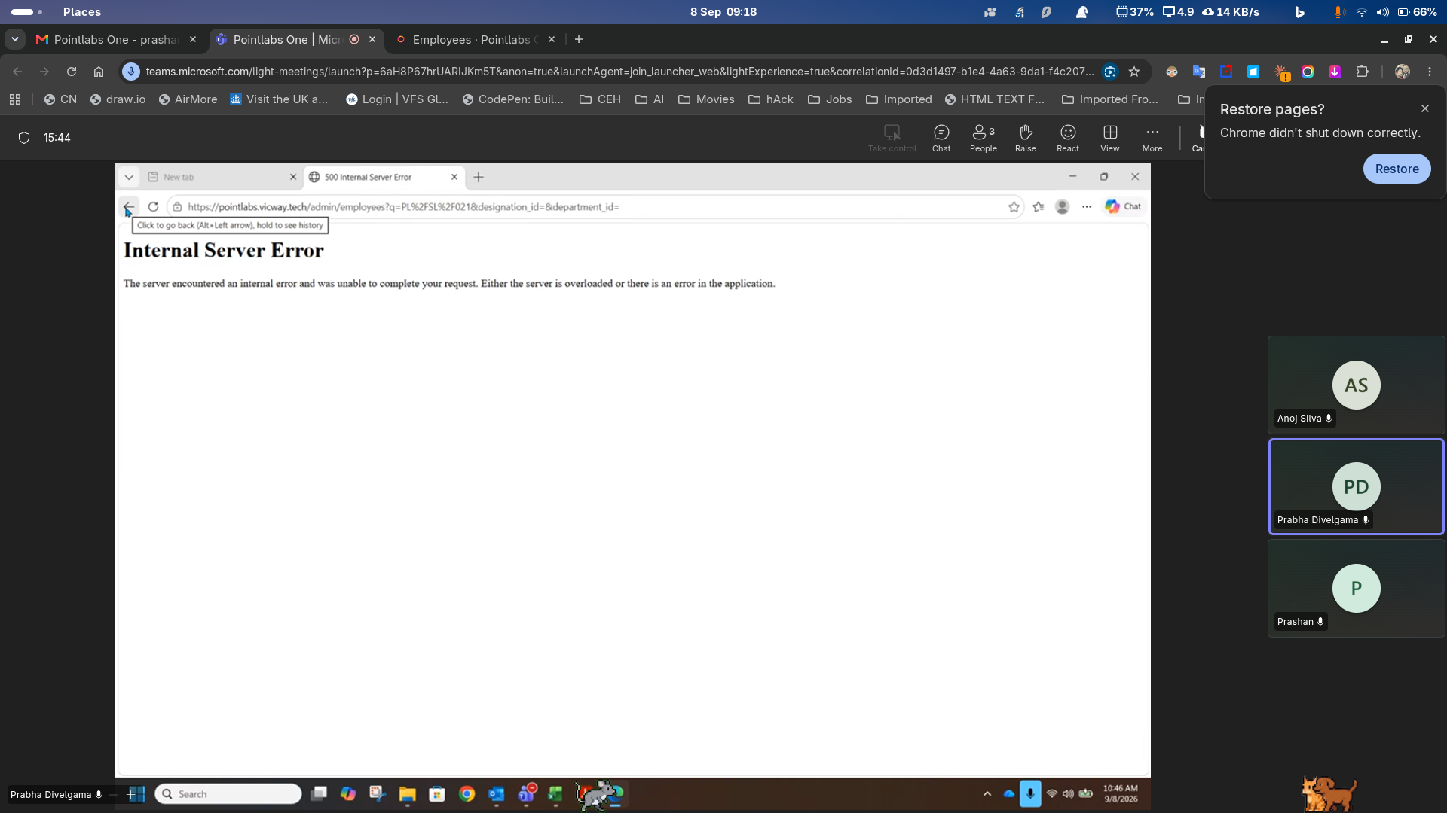
Search eke error ekak enawa
Employee list eken add employee ain karanna oni
Pagination – 10 per page
Add employee – documents upload needs to add
Resignation date eken passe employee diactivate wenna oni, login eka. Eeta amatarawa notification serama ain wenna oni
Leave balace update karanna oni, add employee wala. Eetapasse leave managemenet tab ekak oni, eke passe add karanna puluwn wenna oni.
Department management, Location management add wenna oni.

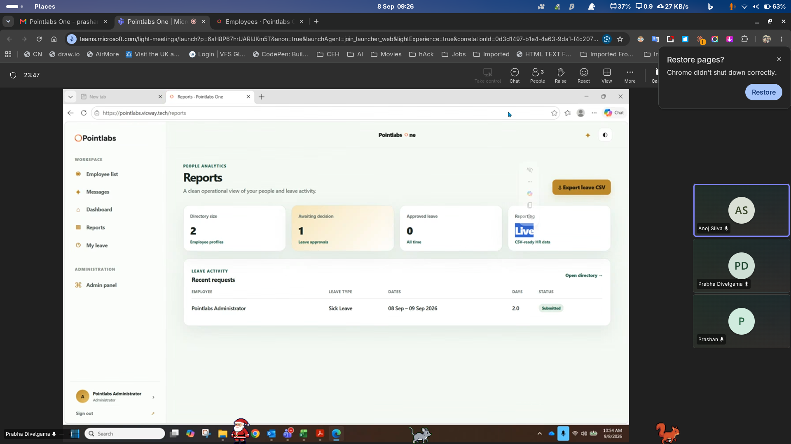
Reporting live – meed to change
First box – Total active Employee

Workspace – Other request – if some one as a salary certificate, or any other thing from the company needs to come there. Visa application support letter, NOC.
Approved leave – need to change other request, sub heading pending request

Reports – Leave summary (Available – Annual/sick, Utilize, Balance), Full employee detail report,

Salary adding – Since we need to have this pay slip sending.

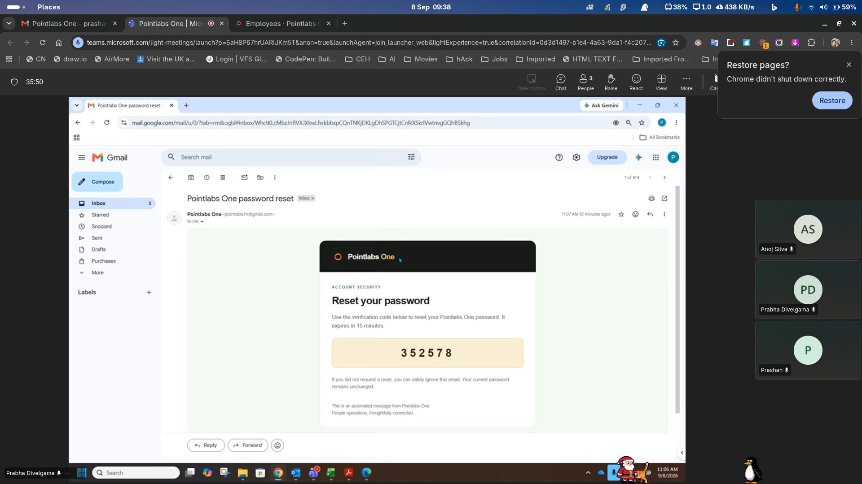
Email template eke icon eka change karanna

Employee details – Home country address, home country contact

